PERTH MODERN SCHOOL
UNIT 3CD MAS – 2014
TEST 1
POLAR COORDINATES, COMPLEX NUMBERS & VECTORS

NAME: DATE: Thurs. 13th Feb.
Total: 43 marks Time: 45 min.

1. Z is a complex number. Sketch the region given by [5]
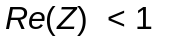 and 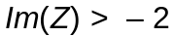
and 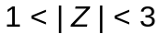
and 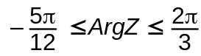

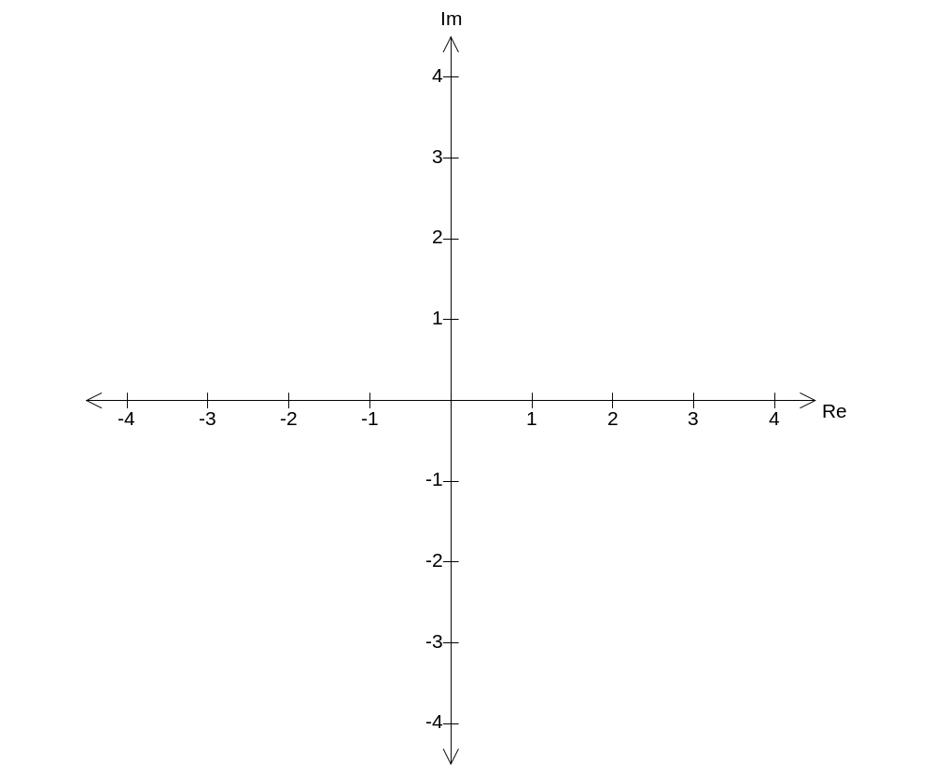

2. Express 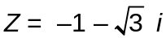 in polar form. [2]

3. If 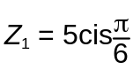 and 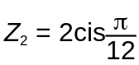 , then prove 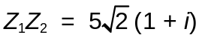 [4]

4. Find 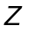 if 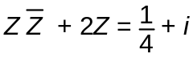 [6]

5. Consider the 3D position vectors [8]
Determine:
a) the length of 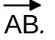

b)

c) the vector equation of the line, in parametric form, through the points A and B.

6. [8]
A has the rectangular coordinates 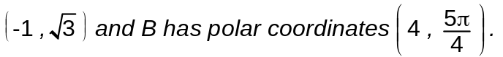

a) What are the exact polar coordinates of A? (1)

b) What are the exact rectangular coordinates of B? (2)

c) The graph of the polar equation 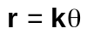 passes through the point B.
If 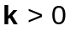, determine the value of k.
Then, on the axes below, sketch the graph of 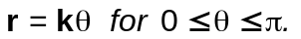,
showing important features. (5)
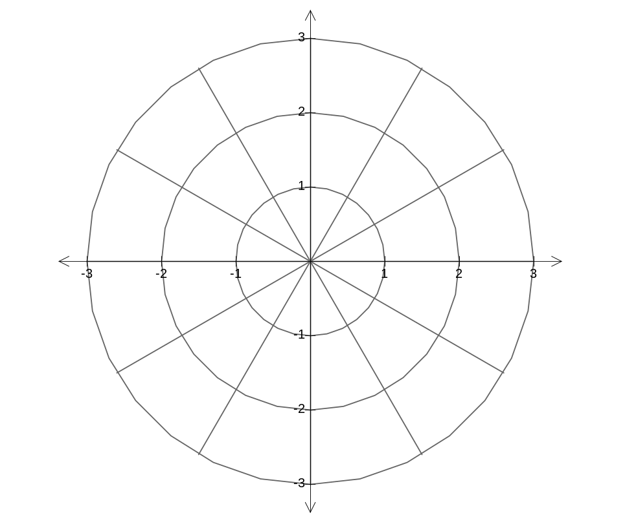

7. [10]
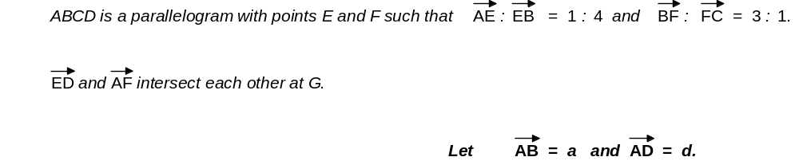

a) Complete the diagram below with the information given above. (2)

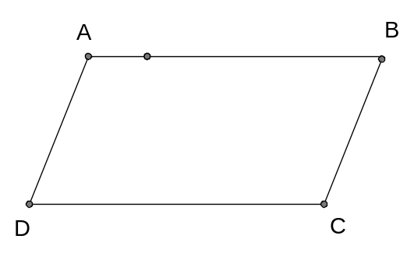

b) Determine the ratios in which 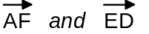 intersect each other, if the intersection point is at G. (8)

